 

# GHARDA FOUNDATION

**GHARDA INSTITUTE OF TECHNOLOGY, LAVEL**

#### Department of Computer Engineering

**Evaluation Sheet**

Class: TE-Computer Engineeing Sem: V Subject: **Computer Networks**

#### Experiment No: 3

#### Title of Experiment: [Basics of Packet Tracer and Network Devices Hub and Switch](https://drive.google.com/file/d/1uQMn8WeCWn0VEWeEtmYb4FUtzgDM8wVN/view?usp=sharing)

#### Name of Student: Harvande Sanket Chandrashekhar Roll No: 19

|  |  |  |  |
| --- | --- | --- | --- |
| Sr. No. | Evaluation Criteria | Max Marks | Marks Obtained |
| 1 | Practical Performance | 8 |  |
| 2 | Oral | 5 |  |
| 3 | Timely Submission | 2 |  |
|  | Total | 15 |  |

Signature of Subject Teacher (Mr. S. S. Tathare)

#### **Aim**: To study [basics of Packet Tracer and Network Devices Hub and Switch](https://drive.google.com/file/d/1uQMn8WeCWn0VEWeEtmYb4FUtzgDM8wVN/view?usp=sharing).

**Apparatus**: Packet Tracer software

**Procedure**:

1. Check for all the components of Packet Tracer GUI.
2. Also check for the different types of network cables available in the software.

3. Configure a LAN using Hub and check the connectivity using ping command as well as real time simulation to study the working of Hub.

4. Configure a LAN using Switch and check the connectivity using ping command as well as real time simulation to study the working of Switch.

**Screenshots**:

HUB :

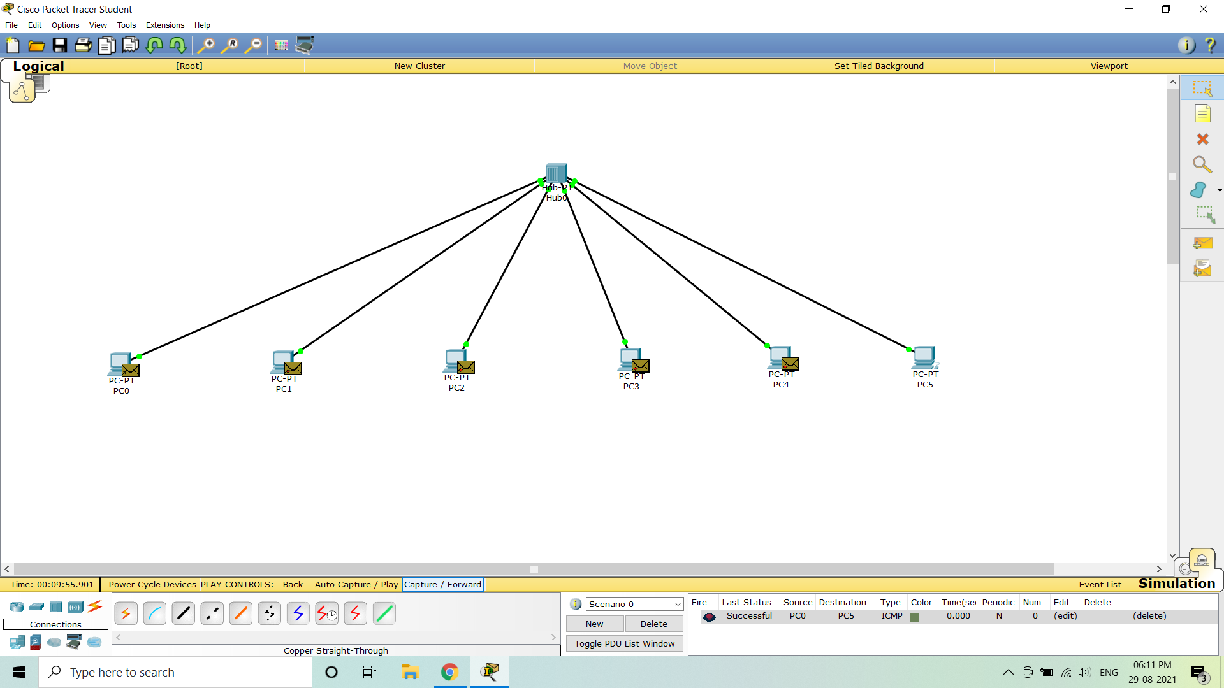

SWITCH :

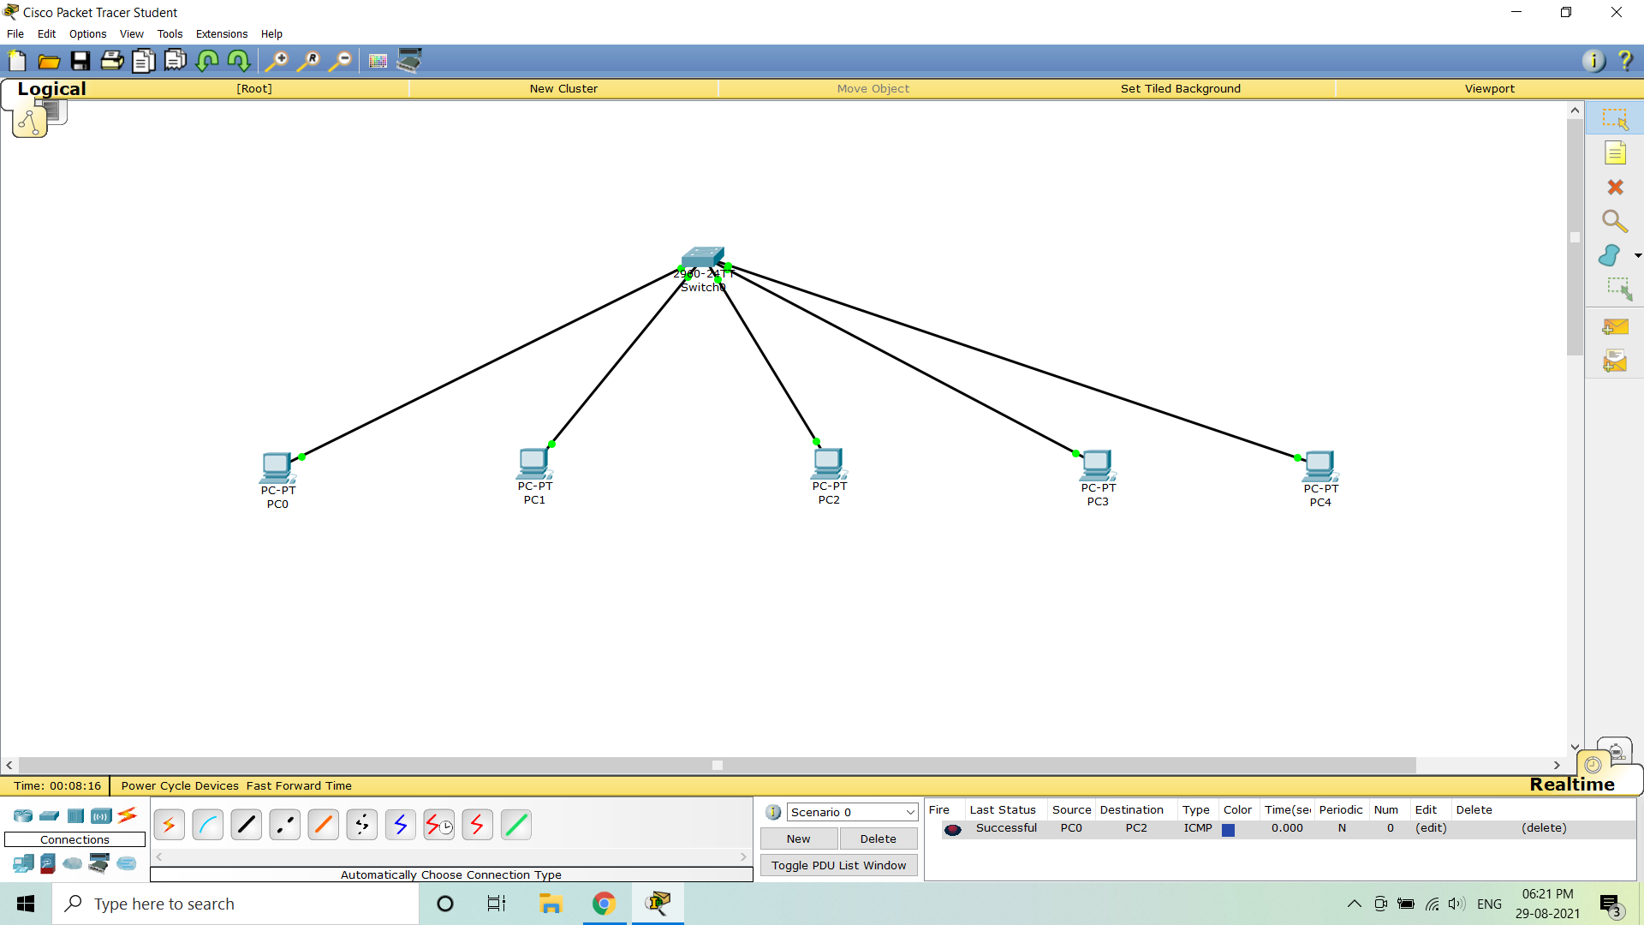

#### **Conclusion**: Thus the study of [basics of Packet Tracer and Network Devices Hub and Switch](https://drive.google.com/file/d/1uQMn8WeCWn0VEWeEtmYb4FUtzgDM8wVN/view?usp=sharing) is done using Packet tracer software.